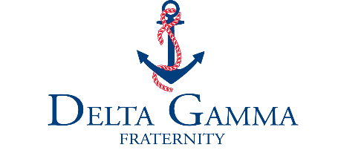

Recommendation Form
This form is for use by members of Delta Gamma only. Please contact the collegiate recruitment specialist
at Executive Offices at 614-481-8169 or at Recommendations@deltagamma.org with any questions.

Voluntary Recommendation Form Requested Recommendation Form Information Only Form

For Chapter of Delta Gamma at
(chapter) (college/university)

CANDIDATE INFORMATION
Name of potential member:
Home address:
Email: Phone:
Entering recruitment as: Freshman Sophomore Junior Senior Age:
High School: High School City/State:
GPA: on a scale of SAT score: ACT score: Class rank: out of

FAMILY INFORMATION
Parent/Guardian name: Fraternity/Sorority: College/University:
Address (if different from above):

Parent/Guardian name: Fraternity/Sorority: College/University:
Address (if different from above):

LEGACY INFORMATION (Delta Gamma mother/stepmother, grandmother, sister/stepsister)
Delta Gamma Mother: Chapter of Initiation: Contact Information:
Delta Gamma Grandmother: Chapter of Initiation: Contact Information:
Delta Gamma Sister: Chapter of Initiation: Contact Information:

Other Delta Gamma relatives:
Other sorority influences:

ADDITIONAL CANDIDATE INFORMATION
Please provide your evaluation of the potential member, relating her qualifications to Article II of the Delta Gamma Constitution. Check all boxes that apply. You may add comments or attach a separate sheet with more details.

Article II of the Delta Gamma Constitution:
The objects of this Fraternity shall be to foster high ideals of friendship among women, to promote their educational and cultural interests, to create in them a true sense of social responsibility, and to develop in them the best qualities of character.

Friendship
Supportive Loyal Dependable/Trustworthy Other:

Education
Honor Student, Advanced Placement courses National Honor Society, scholarships Internships, job shadowing, tutor
Other:

Cultural Interests
Student organizations Musical or artistic involvement Athletic teams Leadership positions Other:

Social Responsibility
Community volunteer Service experiences/mission trips Jobs/summer work Other:

Qualities of Character
Personable/congenial Motivated to succeed Displays integrity Other:

Comments and additional information:
The potential member might enjoy talking about these topics during recruitment:

This form has been completed by:
Submitter name:
Chapter of Initiation: I am an: Alumna Collegian
Email: Phone number:
Home address:

I have known the potential member for years and/or the potential member’s family for years.
or
I do not personally know the potential member; I acquired information from .

I endorse this potential member with the understanding that she may become a new member of Delta Gamma.
or
I do not wish to endorse this potential member. I understand that I may be contacted by a chapter adviser.

Please check box if additional information is attached.

I am in good standing and current with my per capita alumnae dues.

